ITMD 555 Intelligent Devices

HW-2

App Name: Meal Cost Calculator

**Source Code**

File Name: MainActivity.java

**package** com.example.shruti.my1stapp;  
  
  
  
**import** android.database.sqlite.SQLiteDatabase;  
**import** android.support.v7.app.AppCompatActivity;  
**import** android.os.Bundle;  
**import** android.view.View;  
**import** android.widget.Button;  
**import** android.widget.EditText;  
**import** android.widget.TextView;  
  
**import** android.app.Activity;  
**import** android.content.Context;  
**import** android.content.DialogInterface;  
**import** android.support.v7.app.AlertDialog;  
**import** android.text.TextUtils;  
**import** android.util.Log;  
**import** android.view.inputmethod.InputMethodManager;  
**import** com.example.shruti.my1stapp.R;  
  
**public class** MainActivity **extends** AppCompatActivity {  
  
 EditText **mealCostEditView**;  
 EditText **taxPercentEditView**;  
 EditText **tipPercentEditView**;  
 Button **calculateBtn**;  
 TextView **calculateMealCostText**;  
 String **checkInput**,**mealCost**, **tipPercent**, **taxPercent**;  
 Context **context**;  
 @Override  
 **protected void** onCreate(Bundle savedInstanceState) {  
 **super**.onCreate(savedInstanceState);  
 setContentView(R.layout.***activity_main***);  
 **context** = **this**;  
  
 **mealCostEditView** = (EditText) findViewById(R.id.***mealCost***);  
 **taxPercentEditView** = (EditText) findViewById(R.id.***taxPercent***);  
 **tipPercentEditView** = (EditText) findViewById(R.id.***tipPecent***);  
 **calculateBtn** = (Button) findViewById(R.id.***button***);  
 **calculateMealCostText** = (TextView) findViewById(R.id.***calculateCost***);  
 **checkInput** = **"/^-?(0|[1-9]\\d*)(\\.\\d+)?$/"**;  
 addListenerOnButton();  
 }  
  
 **private void** addListenerOnButton() {  
  
  
 **calculateBtn**.setOnClickListener(**new** View.OnClickListener(){  
  
 **public void** onClick(View arg0){  
  
 **double** num1,num2,num3,sum;  
 **mealCost** = (**mealCostEditView**.getText().toString());  
 **tipPercent**=(**taxPercentEditView**.getText().toString());  
 **taxPercent**=(**tipPercentEditView**.getText().toString());  
  
 **if** (TextUtils.*isEmpty*(**mealCost**) || TextUtils.*isEmpty*(**tipPercent**)  
 || TextUtils.*isEmpty*(**taxPercent**)) {  
 AlertDialog.Builder builder = **new** AlertDialog.Builder(**context**);  
 builder.setMessage(**"Fields are empty,Please, fill in all the fields"**);  
 builder.setCancelable(**true**);  
 builder.setPositiveButton(  
 **"OK"**,  
 **new** DialogInterface.OnClickListener() {  
 **public void** onClick(DialogInterface dialog, **int** id) {  
 dialog.cancel();  
 }  
 });  
 AlertDialog alert11 = builder.create();  
 alert11.show();  
  
  
 }  
 **else if**(!TextUtils.*isDigitsOnly*(**mealCost**) && !TextUtils.*isDigitsOnly*(**taxPercent**)  
 && !TextUtils.*isDigitsOnly*(**tipPercent**)) {  
 AlertDialog.Builder builder = **new** AlertDialog.Builder(**context**);  
 builder.setMessage(**"Please enter valid entries and no characters"**);  
 builder.setCancelable(**true**);  
 builder.setPositiveButton(  
 **"OK"**,  
 **new** DialogInterface.OnClickListener() {  
 **public void** onClick(DialogInterface dialog, **int** id) {  
 dialog.cancel();  
 }  
  
 });  
 AlertDialog alert11 = builder.create();  
 alert11.show();  
  
  
 }  
  
 **else**{  
   
  
  
 num1 = Double.*parseDouble*(**mealCostEditView**.getText().toString());  
 num2 = Double.*parseDouble*(**taxPercentEditView**.getText().toString());  
 num3 = Double.*parseDouble*(**tipPercentEditView**.getText().toString());  
 sum = num1 + num1 * (num2 / 100) + num1 * (num3 / 100);  
 **calculateMealCostText**.setText(Double.*toString*(sum));  
 }  
  
  
  
 }  
 });  
 }  
}

File Name: main.xml

*<?***xml version="1.0" encoding="utf-8"***?>*<**RelativeLayout xmlns:android="http://schemas.android.com/apk/res/android"  
 xmlns:app="http://schemas.android.com/apk/res-auto"  
 xmlns:tools="http://schemas.android.com/tools"  
 android:layout_width="match_parent"  
 android:layout_height="match_parent"  
 tools:context="com.example.shruti.my1stapp.MainActivity"**>  
  
 <**TextView  
 android:id="@+id/textView"  
 android:layout_width="wrap_content"  
 android:layout_height="wrap_content"  
 android:layout_alignParentLeft="true"  
 android:layout_alignParentStart="true"  
 android:layout_alignParentTop="true"  
 android:layout_marginLeft="32dp"  
 android:layout_marginStart="32dp"  
 android:layout_marginTop="67dp"  
 android:text="Meal Cost $"** />  
  
 <**EditText  
 android:id="@+id/mealCost"  
 android:layout_width="wrap_content"  
 android:layout_height="wrap_content"  
 android:layout_alignBottom="@+id/textView"  
 android:layout_toEndOf="@+id/textView3"  
 android:layout_toRightOf="@+id/textView3"  
 android:ems="10"  
 android:inputType="textPersonName"** />  
  
 <**TextView  
 android:id="@+id/textView2"  
 android:layout_width="wrap_content"  
 android:layout_height="wrap_content"  
 android:layout_alignLeft="@+id/textView"  
 android:layout_alignStart="@+id/textView"  
 android:layout_below="@+id/textView"  
 android:layout_marginTop="37dp"  
 android:text="Tax Percentage %"** />  
  
 <**EditText  
 android:id="@+id/taxPercent"  
 android:layout_width="wrap_content"  
 android:layout_height="wrap_content"  
 android:layout_alignBaseline="@+id/textView2"  
 android:layout_alignBottom="@+id/textView2"  
 android:layout_toEndOf="@+id/textView2"  
 android:layout_toRightOf="@+id/textView2"  
 android:ems="10"  
 android:inputType="textPersonName"** />  
  
 <**TextView  
 android:id="@+id/textView3"  
 android:layout_width="wrap_content"  
 android:layout_height="wrap_content"  
 android:layout_alignLeft="@+id/textView"  
 android:layout_alignStart="@+id/textView"  
 android:layout_below="@+id/taxPercent"  
 android:layout_marginTop="63dp"  
 android:text="Tip Percentage %"** />  
  
 <**EditText  
 android:id="@+id/tipPecent"  
 android:layout_width="wrap_content"  
 android:layout_height="wrap_content"  
 android:layout_alignBottom="@+id/textView3"  
 android:layout_alignLeft="@+id/taxPercent"  
 android:layout_alignStart="@+id/taxPercent"  
 android:ems="10"  
 android:inputType="textPersonName"** />  
  
 <**Button  
 android:id="@+id/button"  
 android:layout_width="wrap_content"  
 android:layout_height="wrap_content"  
 android:layout_alignParentBottom="true"  
 android:layout_marginBottom="42dp"  
 android:layout_toEndOf="@+id/textView3"  
 android:layout_toRightOf="@+id/textView3"  
 android:text="CALCULATE"** />  
  
 <**TextView  
 android:id="@+id/textView4"  
 android:layout_width="wrap_content"  
 android:layout_height="wrap_content"  
 android:layout_alignEnd="@+id/textView3"  
 android:layout_alignRight="@+id/textView3"  
 android:layout_below="@+id/textView3"  
 android:layout_marginTop="83dp"  
 android:text="Total Meal Cost"** />  
  
 <**EditText  
 android:id="@+id/calculateCost"  
 android:layout_width="wrap_content"  
 android:layout_height="wrap_content"  
 android:layout_alignTop="@+id/textView4"  
 android:layout_toEndOf="@+id/textView4"  
 android:layout_toRightOf="@+id/textView4"  
 android:ems="10"  
 android:inputType="textPersonName"** />  
</**RelativeLayout**>

Screenshots:

1st Screen:

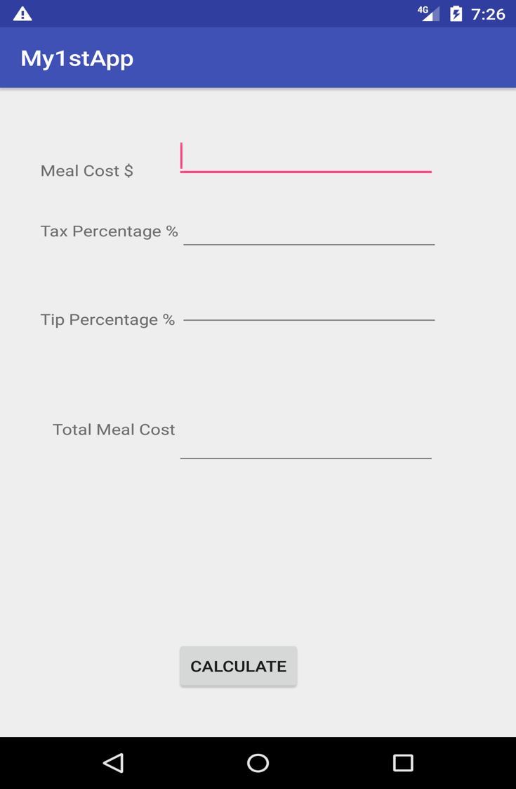

2nd Screen

When the fields are empty and the user clicks on calculate Button.

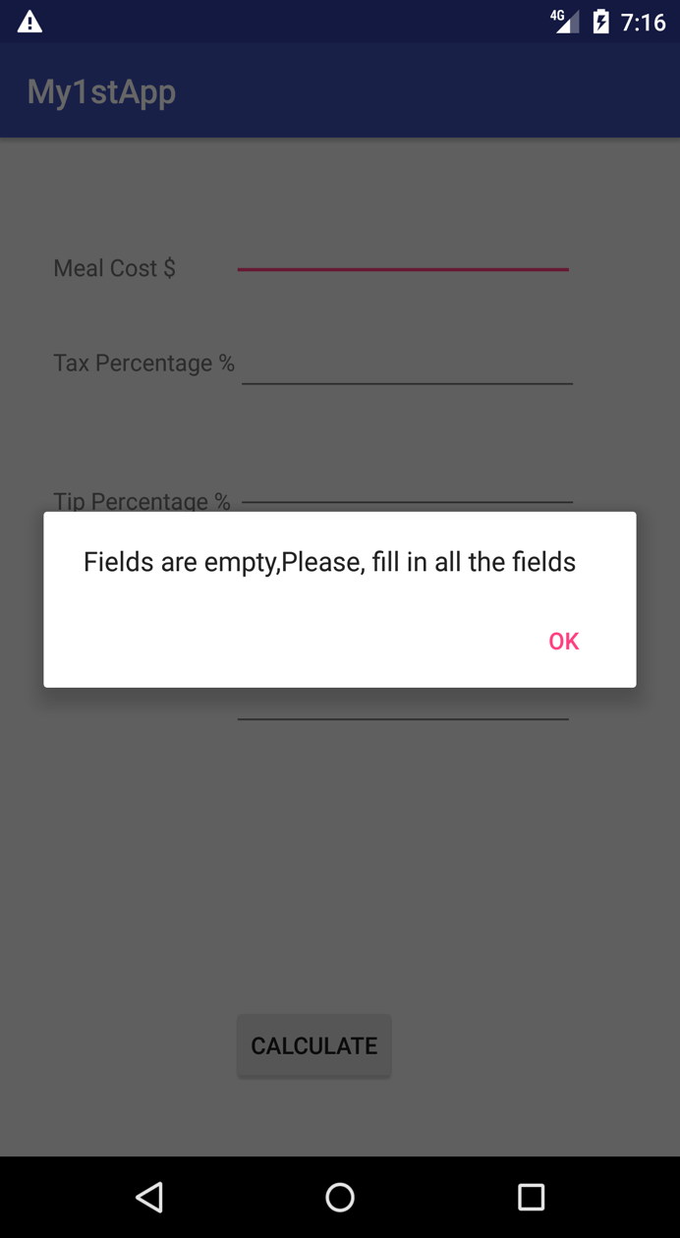

3rd Screen:

When the user tries to put invalid characters, an alert message is shown.

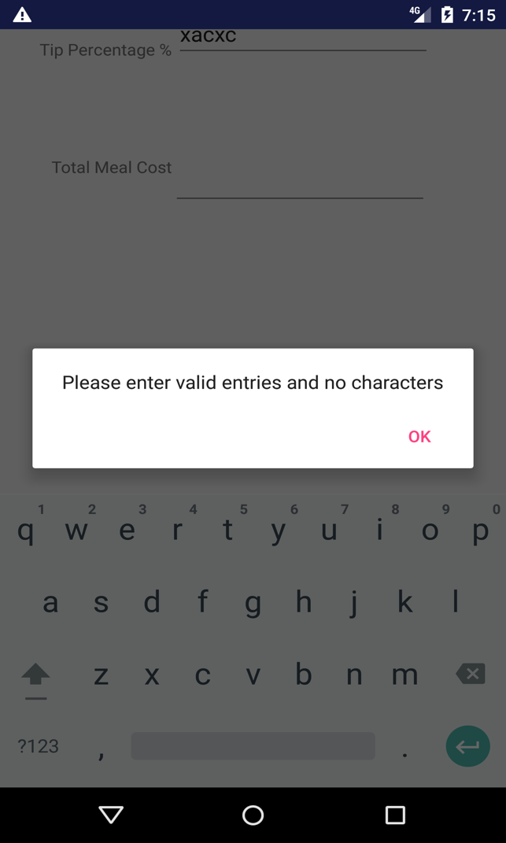

4rth Screen:

Screenshot of the final screen after calculating the total meal cost:

